Try to keep answers between 1-220 words.

Q1)
The Consulting.accdb database depicted in the following relationships diagram keeps track of projects for a small consulting company, including information about the client who requested the project and the employee in charge of the project. Use this diagram for this question and the next one:
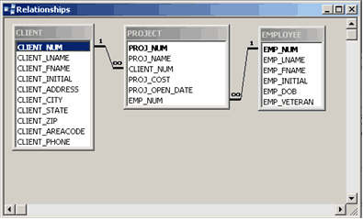
Assume that referential integrity has been enforced in the relationship between the CLIENT and PROJECT tables.
a) Describe what impact this has on the data in both of the tables (refer to specific field names and table names)
b) Assume that “ Cascade Updates” and “Cascade Deletes” are not checked. Describe the implication this has on the data in both tables, using specific table and field names in your response.

Q2)
Using the diagram from question 1, describe the relationship between the EMPLOYEE and PROJECT tables.
In your description, include details about the relationship type, the primary key and the foreign key.
Use specific field and table names in your response.

Q3)
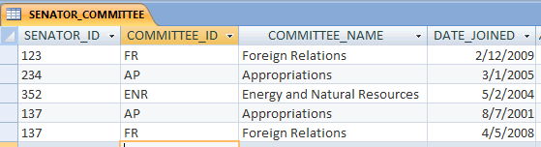

The diagram above shows a table that keeps track of senators and their committee memberships (the DATE_JOINED field is that date that a specific senator joined a specific committee). The primary key in this table is a composite key that consists of the SENATOR_ID field and the COMMITTEE_ID field.
Identify the normal form of the table in the diagram. Describe why it is in that normal form and what you could do (specifically) to change it to third normal form. Use specific field and table names in your response.

